Selenium Web Table Automation Programs

Program 1: Display All Table Rows and Data
Purpose: Finds table1, counts its rows including the header, and prints each row's cell values.
from selenium import webdriver
from selenium.webdriver.common.by import By
driver = webdriver.Chrome()
try:
driver.get("https://the-internet.herokuapp.com/tables")
driver.maximize_window()
table = driver.find_element(By.ID, "table1")
rows = table.find_elements(By.TAG_NAME, "tr")
print("Total rows including header:", len(rows))
for row in rows:
cells = row.find_elements(By.TAG_NAME, "th")
if not cells:
cells = row.find_elements(By.TAG_NAME, "td")
row_data = [cell.text for cell in cells]
print(row_data)
finally:
driver.quit()

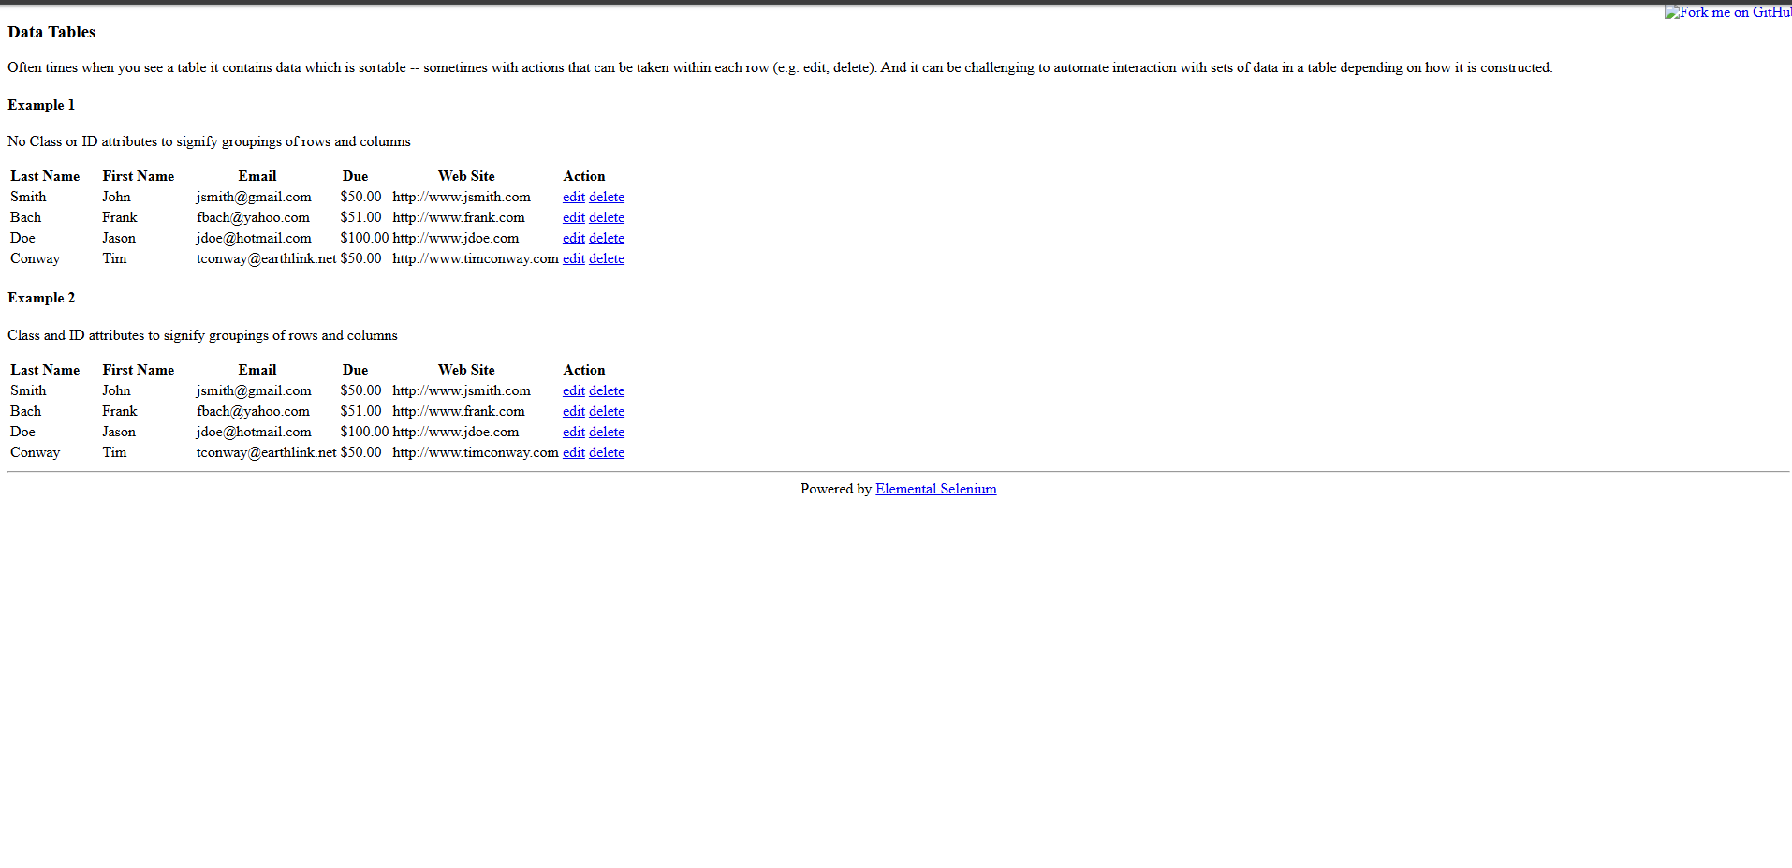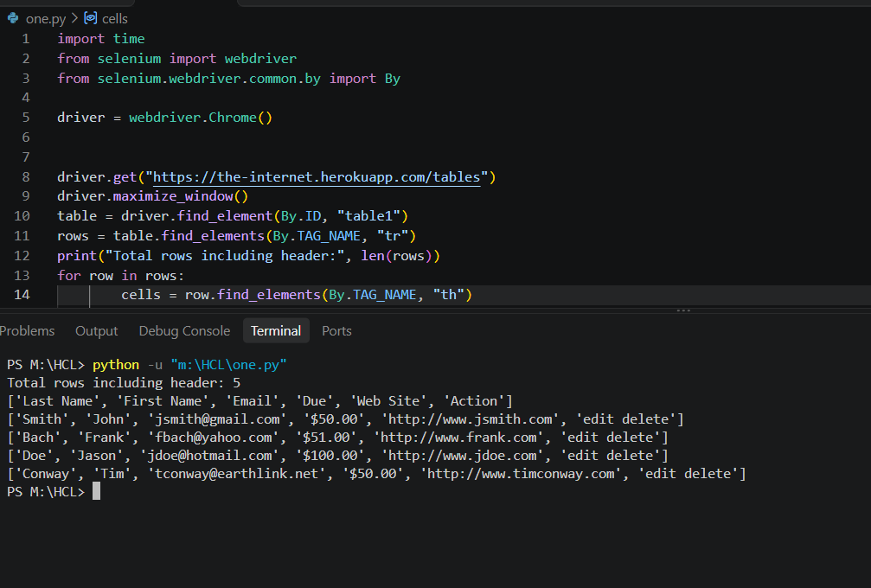

Program 2: Display the First Data Row
Purpose: Reads the first data row and prints the last name, first name, and email.
from selenium import webdriver
from selenium.webdriver.common.by import By
driver = webdriver.Chrome()
try:
driver.get("https://the-internet.herokuapp.com/tables")
table = driver.find_element(By.ID, "table1")
rows = table.find_elements(By.CSS_SELECTOR, "tbody tr")
first_row = rows[0]
cells = first_row.find_elements(By.TAG_NAME, "td")
print("Last Name:", cells[0].text)
print("First Name:", cells[1].text)
print("Email:", cells[2].text)
finally:
driver.quit()
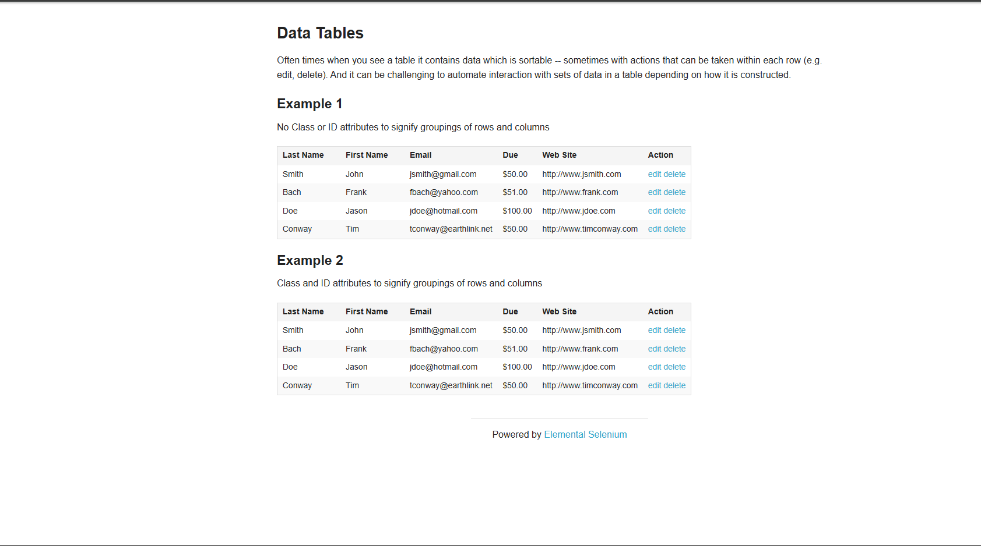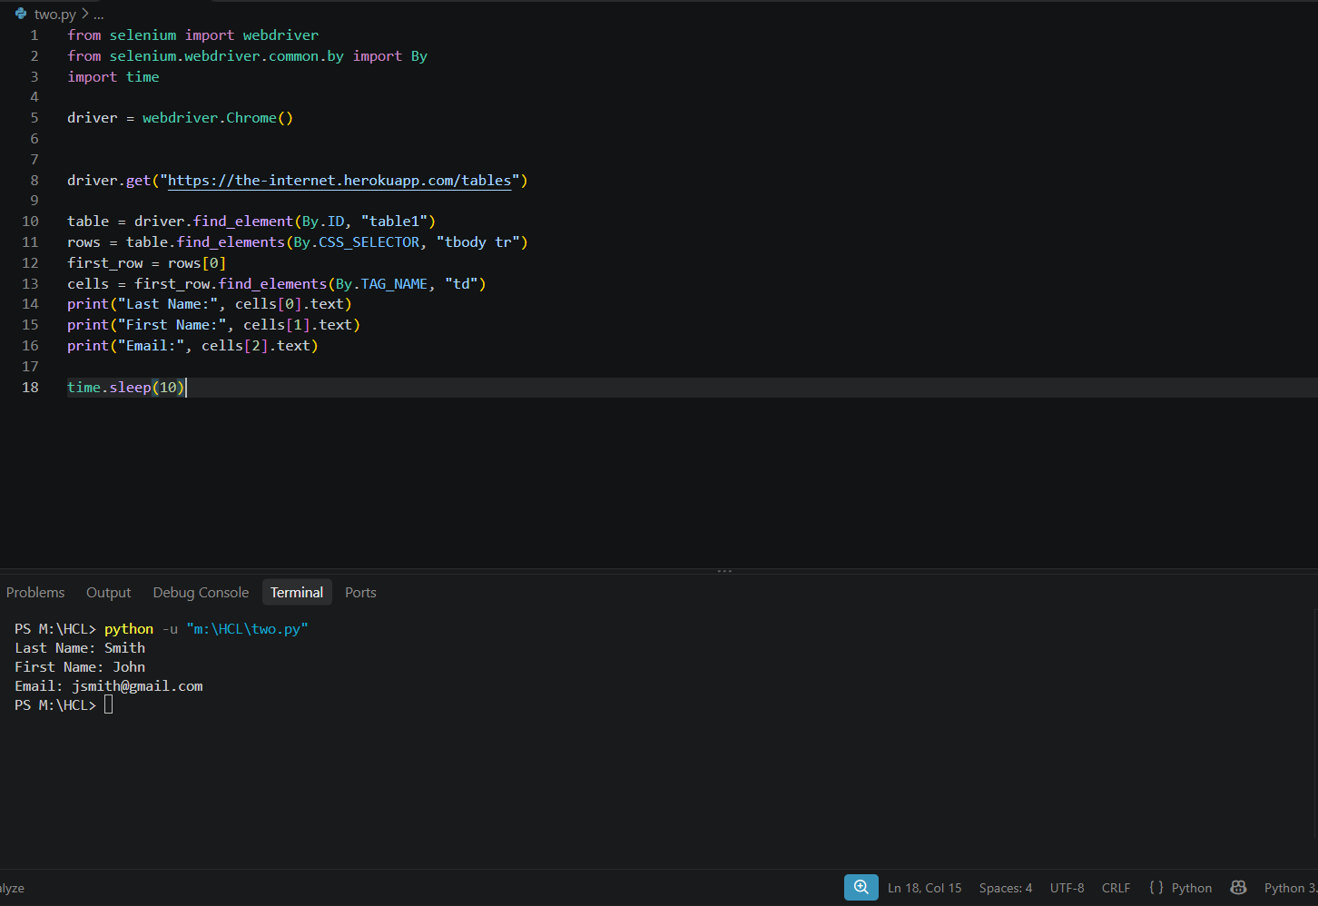

Program 3: Search for an Employee by First Name
Purpose: Searches the first-name column for an exact match to John and prints the matching row.
from selenium import webdriver
from selenium.webdriver.common.by import By
driver = webdriver.Chrome()
try:
driver.get("https://the-internet.herokuapp.com/tables")
rows = driver.find_elements(By.CSS_SELECTOR, "#table1 tbody tr")
search_name = "John"
found = False
for row in rows:
cells = row.find_elements(By.TAG_NAME, "td")
first_name = cells[1].text
if first_name == search_name:
print("Employee found!")
print("Employee details:", row.text)
found = True
break
if not found:
print("Employee not found")
finally:
driver.quit()

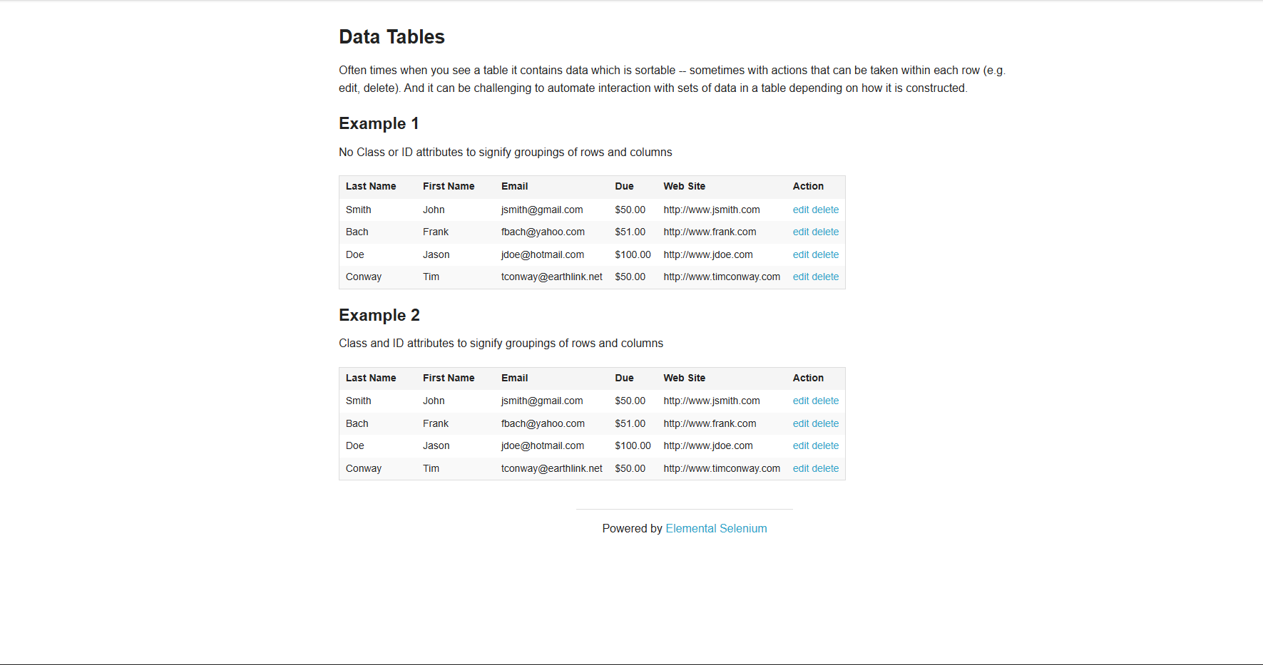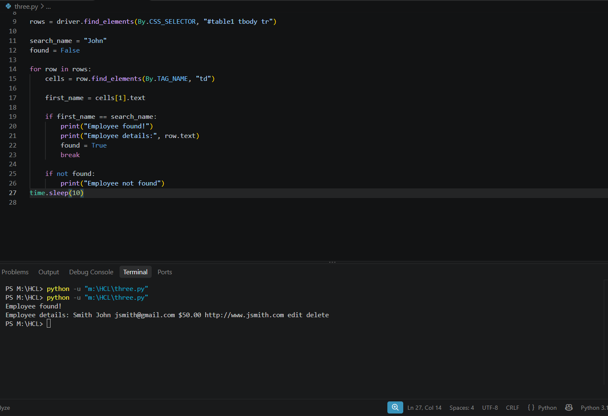

Program 4: Count Table Rows and Columns
Purpose: Counts the data rows without the header and counts the table's header columns.
from selenium import webdriver
from selenium.webdriver.common.by import By
driver = webdriver.Chrome()
try:
driver.get("https://the-internet.herokuapp.com/tables")
table = driver.find_element(By.ID, "table1")
rows = table.find_elements(By.CSS_SELECTOR, "tbody tr")
headers = table.find_elements(By.CSS_SELECTOR, "thead th")
print("Number of data rows:", len(rows))
print("Number of columns:", len(headers))
finally:
driver.quit()
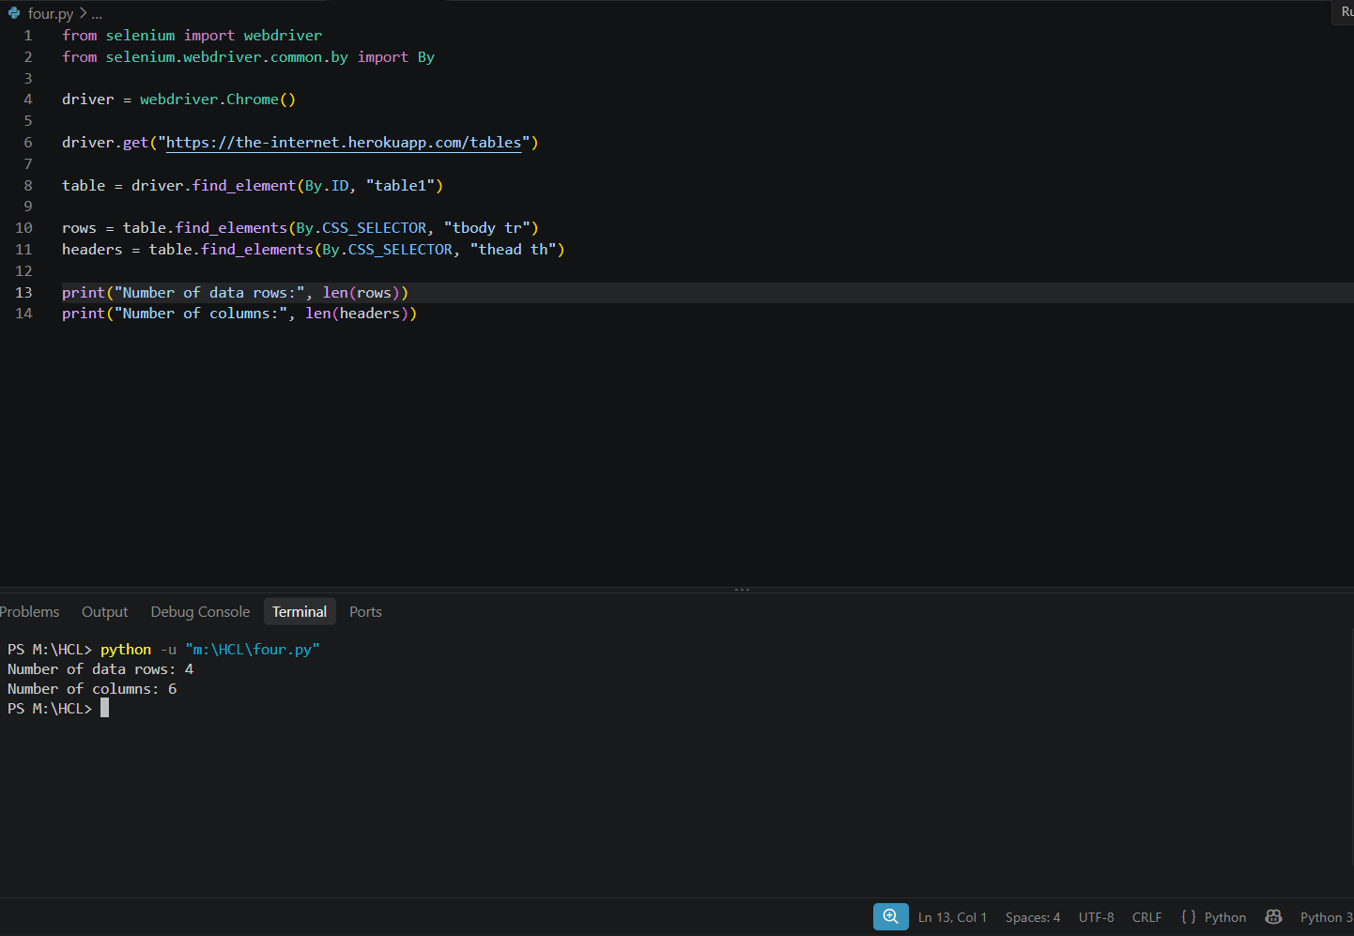

Github:
https://github.com/Virumaaharish/Selenium-web-Table-Automation

